SeaPerch After School Program for 4th Grade Students
Thursdays from 3:30 - 5:00
May 3rd, 10th, 17th, 24th and 31st
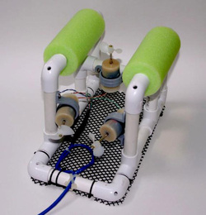
SeaPerch is an innovative underwater robotics program that teaches teachers and students to build an underwater Remotely Operated Vehicle (ROV) in either a classroom or out-of-school setting. Students build the ROV from a kit comprised of low-cost, easily accessible parts, following a curriculum that teaches science, technology, engineering and mathematics (STEM) with a marine engineering theme. Throughout the project, students will learn engineering concepts, problem solving, design skills, and teamwork.

The final session will be on a Saturday June 2nd at Belmont Harbor to test the ROV. Parents will be asked to attend this session with their child. .

You may email me with any questions you have about this program. Kmmalhiot@cps.edu.

Due to the limited number of spaces available for this program interested students will need to complete the following essay questions:

- Why are you interested in this program, and are you able to commit the time?
- The ROV will be built as a team, explain what skills you will bring to the program that will help your team.
- Why do you feel it’s important to learn STEM (Science, Technology, Engineering and Math) skills?

If more students respond then we are able to accommodate in the program we will have a lottery for the available spaces.

----------------------------------------------------------------------------------------------------------------------------------------
Please return this section with the essay questions by Monday, April 23rd.

Parents please sign below indicating your willingness to have your child participate in this program.

- I am willing to have my child attend this afterschool program.

- I will attend the Saturday June 2nd session with my child.

Child’s Name _________________________________

Parent Signature __________________________________

